

Directions For NEW PIVOT USERS: Location of Website, Logging In,
& Changing Your Password

Website: https://avondale.five-starpivot.com

Log In information:
Username: Your Avondale District Email
Example: Micky.Mouse@avondale.k12.mi.us
Temporary Password: Changeme!
***You will need to log in and change your password.


Pivot Log In Page

Click on your initials.

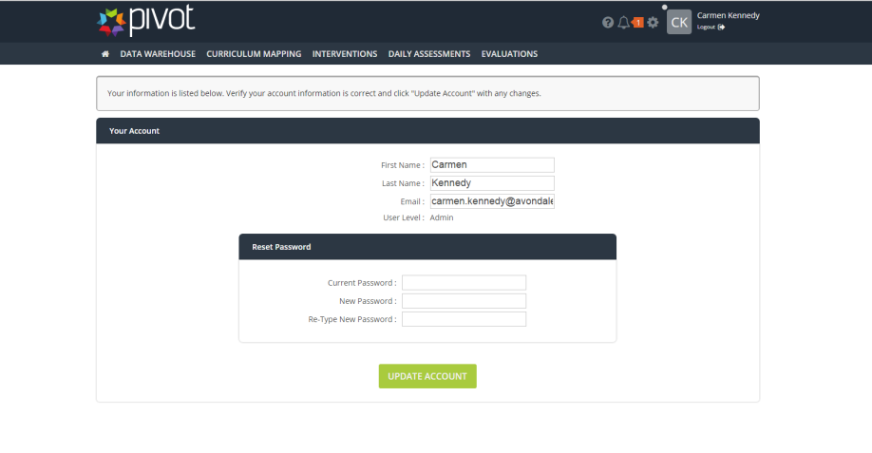
Change your password.
Change your password.

